Most likely workflow

Patient’s Chart > Blank Forms > Referral --- this is just a form.

Does this write out to a table and is it the proper form to refer a patient.

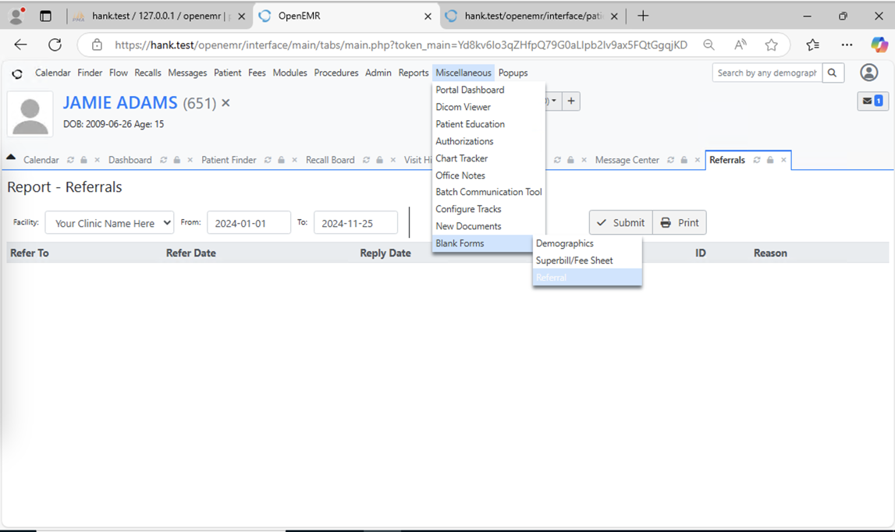

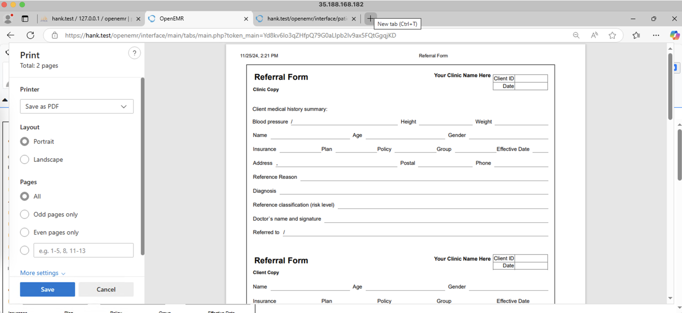

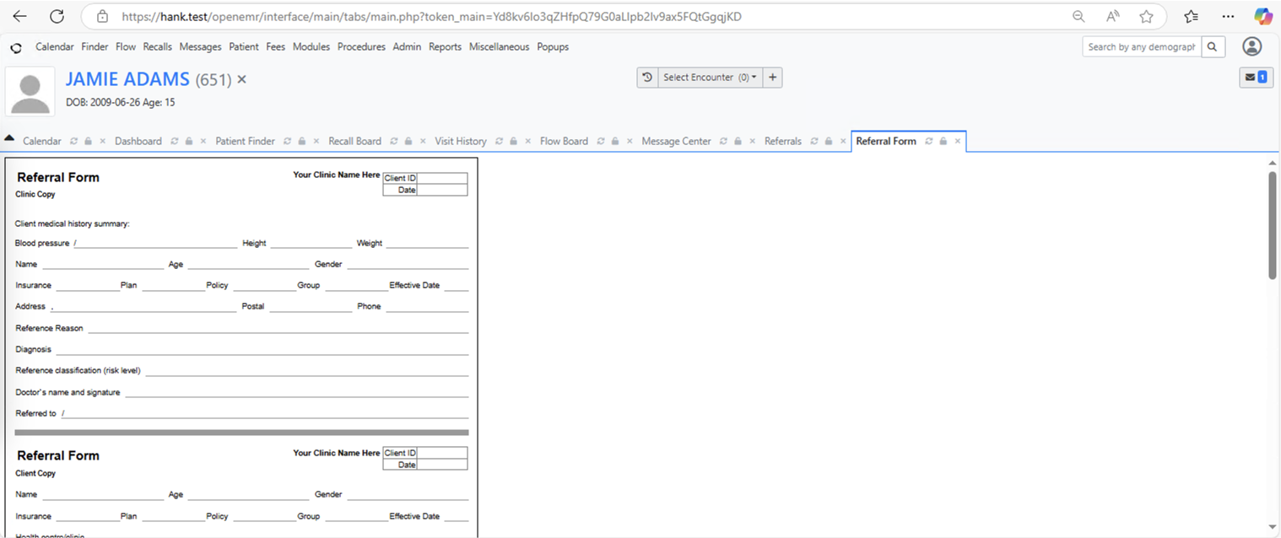

Other workflow:

Patient’s Chart > Reports > Clients > Referrals

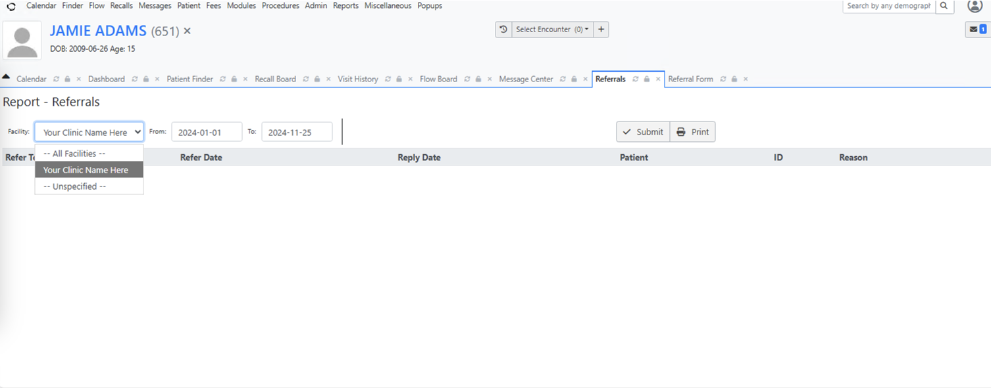

? maybe something I left open?

<https://hank.test/openemr/interface/patient_file/report/custom_report.php?printable=1&include_demographics=demographics&include_billing=billing&pdf=0&newpatient_74=170&surgery_clearance_1=170&track_anything_2=170&>

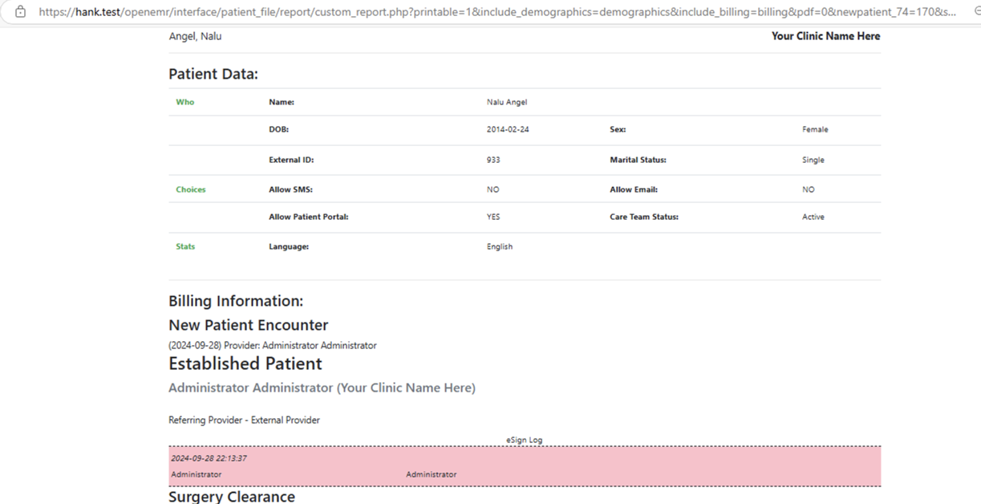

**EXPLORATORY**

  
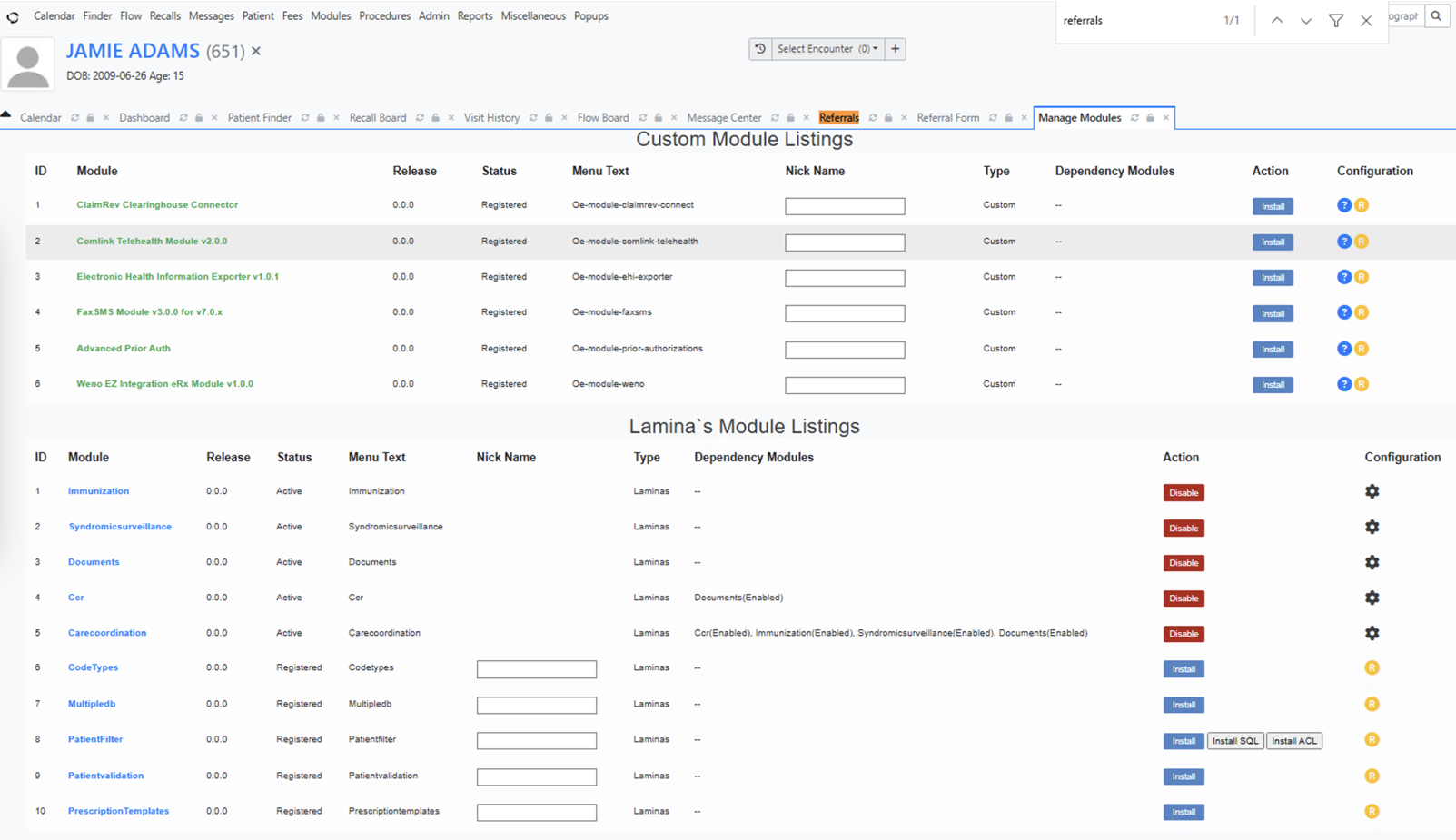

IMPLEMENTATION

